
1

PROJECT TEAM CONTRACT

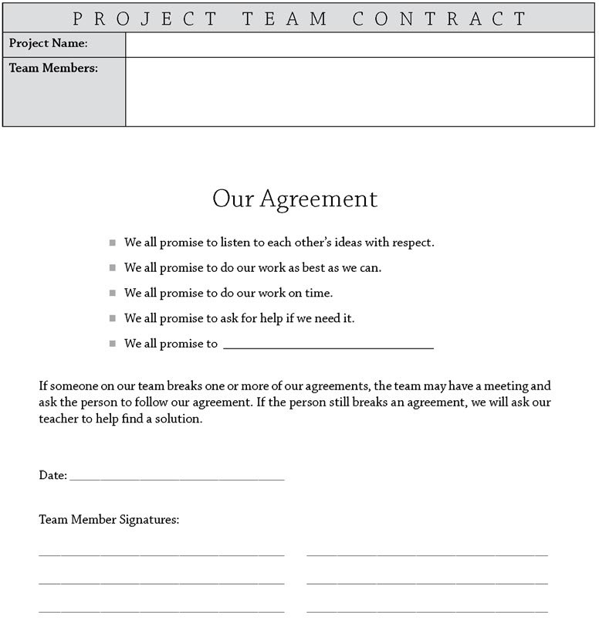

pblworks.org
© 2019 Buck Institute for Education

