
1
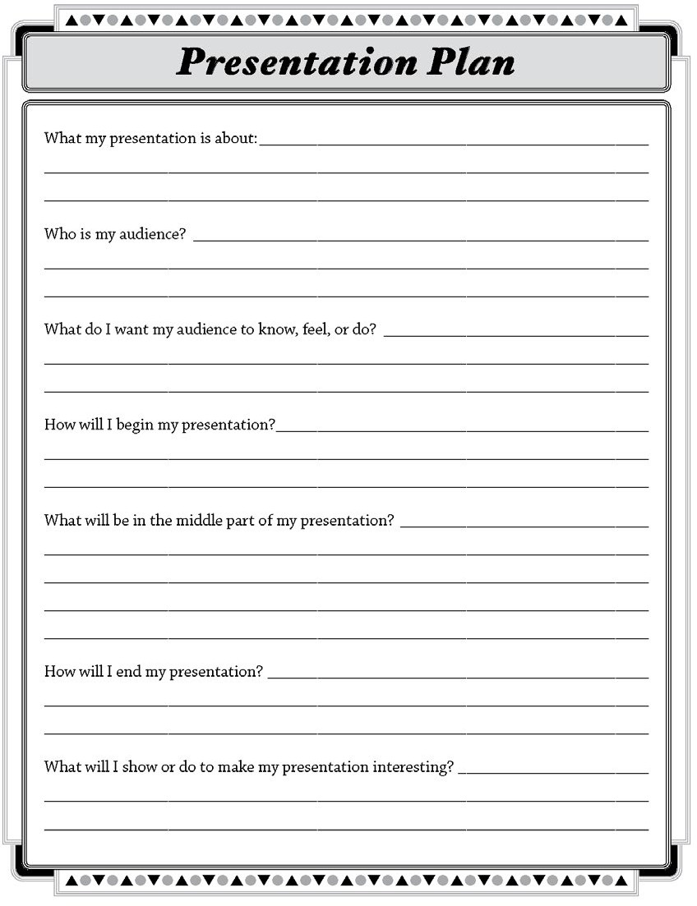

pblworks.org
© 2019 Buck Institute for Education

